AWS - How to resize VM to different family.

Before the activity starts for safer side it will be best to take an AMI of the Machine.

**Installing and Upgrading AWS PV Drivers:**

**Step:1** Login into the server and download latest PV drivers. Extract the zip file and install AWSPVDriverSetup.msi. Once you install the drive, the server will automatically reboot.

**Note:** Login the Server with Administrator privileges

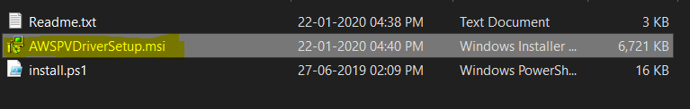

**Installing and Upgrading ENA**

**Step:2** After the reboot, Login into the server again to install AwsEnaNetworkDriver. To do that Right click install.ps1 and run with power shell.

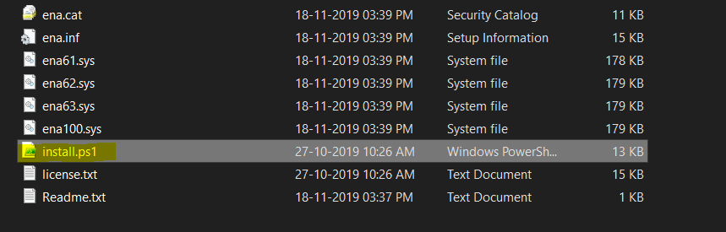

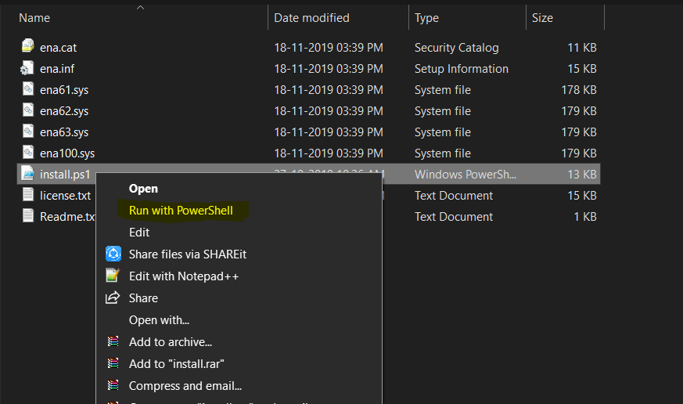

**Note:** No Reboot Needed.

**Upgrading AWS NVMe Drivers**

**Step:3** Once installed the ENA. Need to install NVM2 Drivers. Frist Right Click on install.ps1 and run with Power shell.

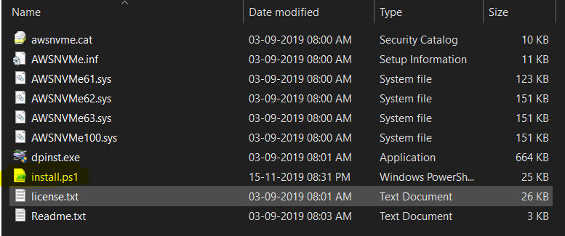

Once that completed, Install the driver by running **dpinst.exe.** No reboot needed.

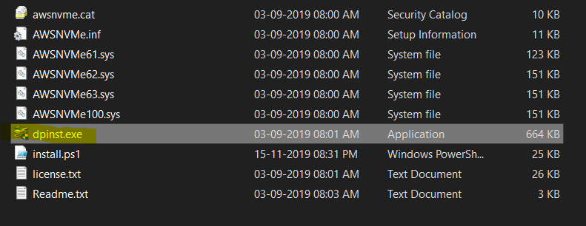

**Updating EC2Config and EC2Launch**

**Step:4** Finally run the EC2Install.exe to update the EC2Config. You can use the below link to download the EC2install.

<https://s3.amazonaws.com/ec2-downloads-windows/EC2Config/EC2Install.zip>.

**For further clarification, Find the AWS link below.**

<https://docs.amazonaws.cn/en_us/AWSEC2/latest/WindowsGuide/migrating-latest-types.html#upgrade-pv>

Once the Resize completed as usual in the AWS portal.

If the server was in domain, release the server from domain to workgroup and then add the server to domain again and then check if we can login properly.